|  |  |
| --- | --- |
| Team ID | PNT2022TMID14185 |
| Project Name | Smart farmer-IOT Enabled smart farming application |

**AN ACCOUNT WAS CREATED IN MIT APP INVENTOR AND FEATURES WERE OVERVIEWED**

**DESIGNER**

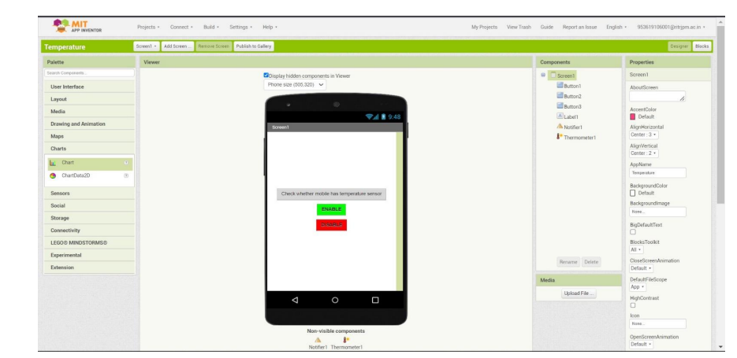

**BLOCKS**

